Project Based Learning Program (PBLP)
31st August, 2022

A Project Based Learning Program was conducted by the Department of English, Duliajan College, on 31st August, 2022.
Program Coordinator: Mrs. Jyoti Singh Pathak, Associate Professor and Head, Department of English, Duliajan College.
Broad Objectives of the Program:
- Learn Communication Skills.
- Enhance self confidence.
- Explore career opportunities in film making/journalism.
- Develop meta-cognitive skills.
Specific Learning Outcome:
- Networking and interpersonal skills.
- Learn to frame appropriate questions for an interview.
- Learn body language and social etiquettes.
- Develop active listening skills.
- Get a broad idea about film making.
- Learn translation/transcription skills from one language to other.
- Enhance four basic English skills:- Listening, Speaking, Reading and Writing.
Target Group: Semester III and Semester V English Honours Students.
Program Plan:
The students of English Honours interviewed Mr. Jadumoni Dutta a renowned Assamese Film/Documentary Director, recognized at the state and national level for his work.
The following students along with two faculty members visited the office of the personality and collected wide ranging information on various aspects of film making and direction through a face to face interview with him.
Names of the Students Faculty Members
Ms. Krishna Priya Deka (Sem V) Mrs. Jyoti Singh Pathak
Ms. Akrishtha Dutta (Sem III) Mr. Gaurab Sengupta
Ms. Shikhamoni Deka (Sem III)
Mr. Sharat Sharma (Sem III)

Prior to the interview, the students were provided a training on the following aspects by Mrs. Jyoti Singh Pathak:
- Framing questions for face to face, personality interviews- open ended, probing, closed and follow up types.
- Body language and etiquette.
Further, a training on translation and transcription from Assamese language to English for publishing the interview in DiscourseZ- the students’ departmental journal was provided by Mr. Gaurab Sengupta.
Mrs. Pinky Sharma Saikia and Mrs. Nirupama Dey guided the students on question compilation for the interview.
The interview was conducted by Ms. Krishna Priya Deka of V Sem and Ms. Akrishtha Dutta of III Sem.

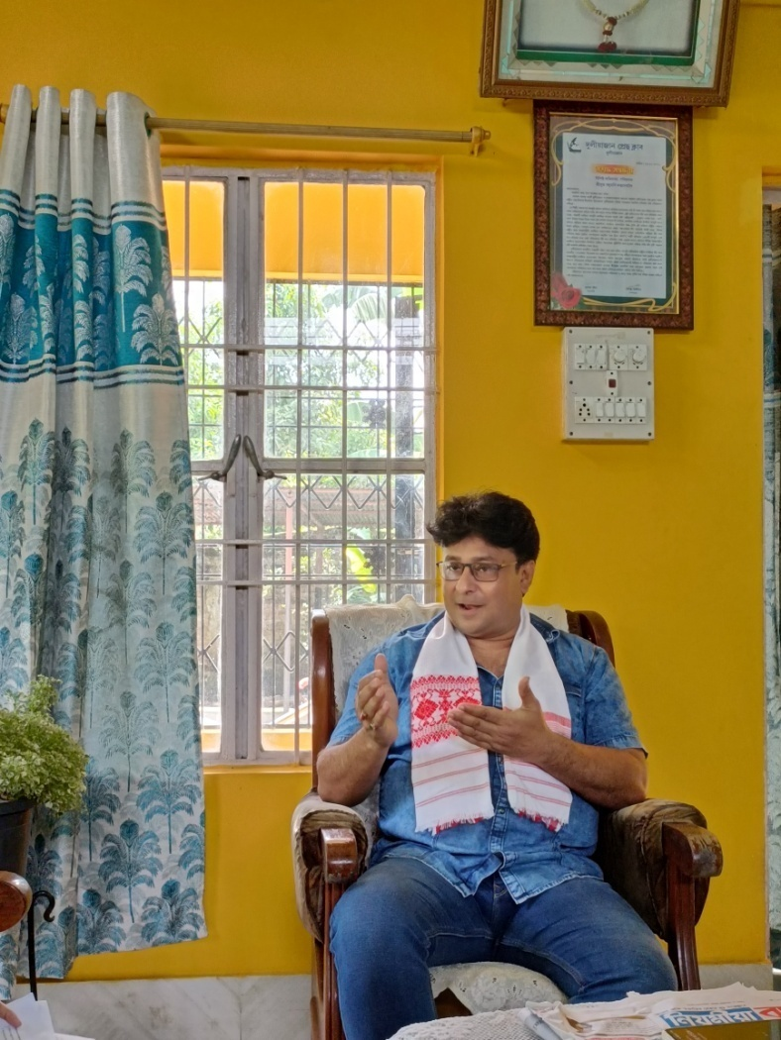

Mr. Jadumoni Dutta: renowned Assamese Film/Documentary Director

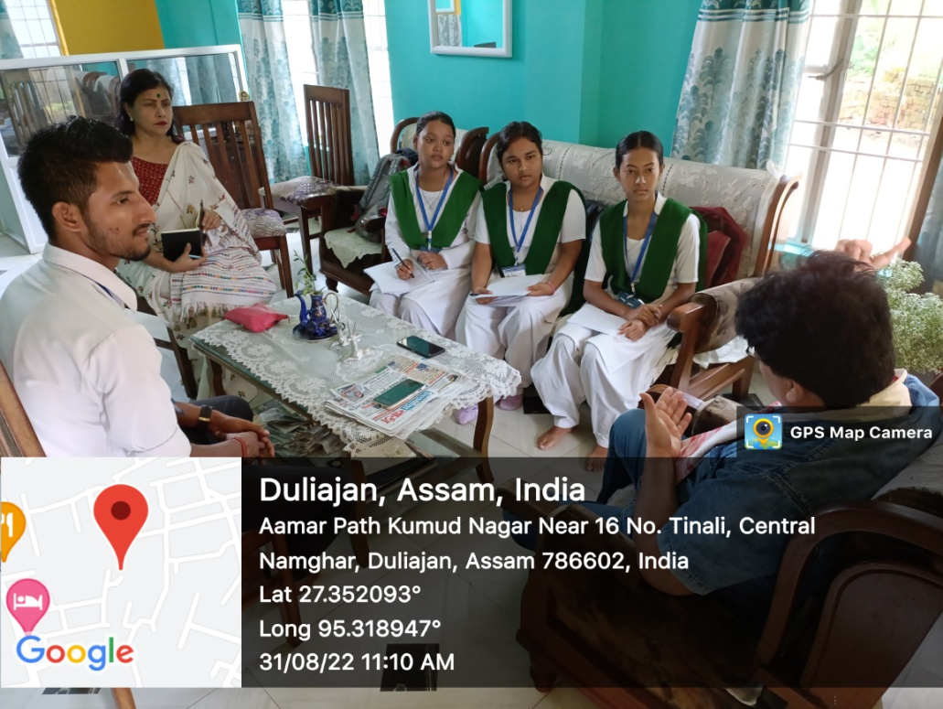

Students with the Programme Coordinator Mrs. Jyoti Singh Pathak, HOD, English, Duliajan College, interviewing the director.

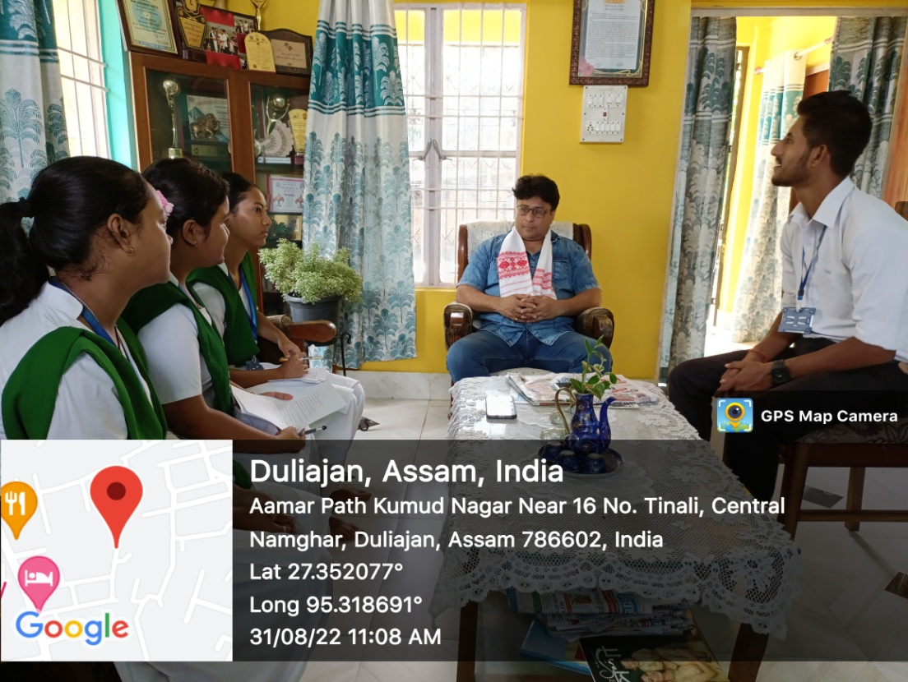
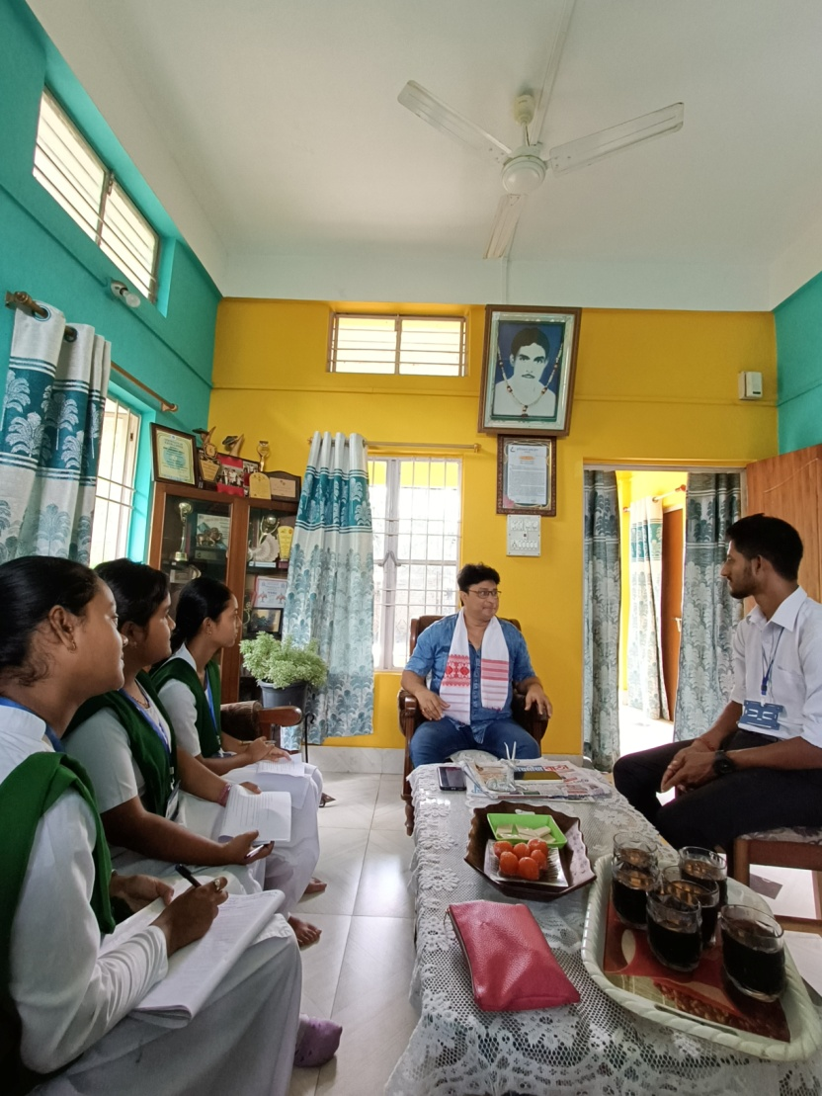

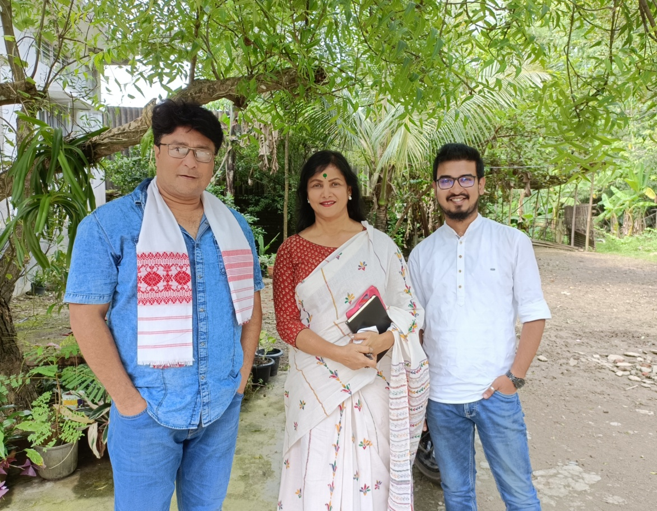
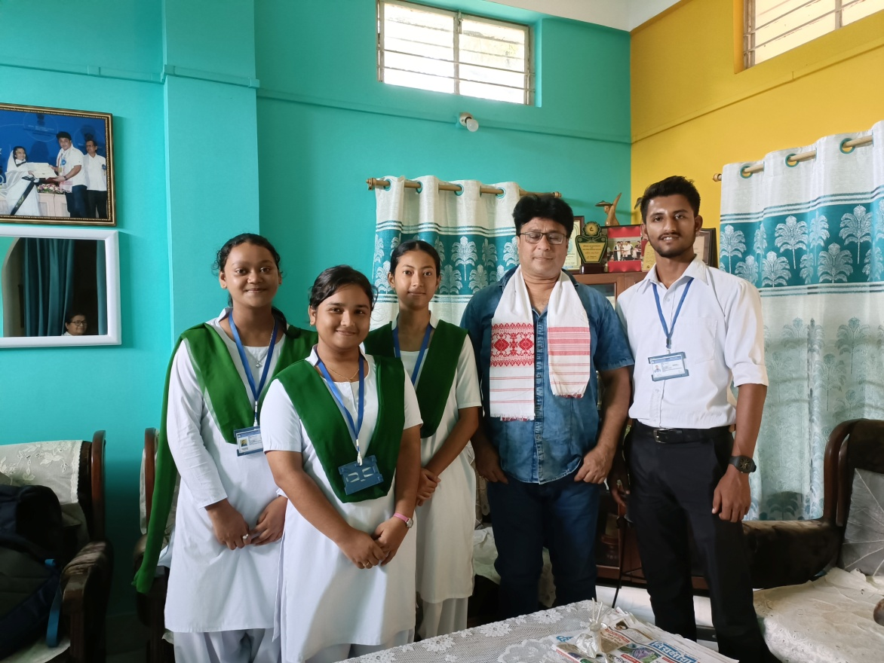
Faculty Members Mrs. Jyoti Singh Pathak and Mr. Gaurab Sengupta with Mr. Dutta
The students along with Mr. Dutta

