A Lecture on Indian Diasporic Novels: An Overview
and
Screening and critical analysis of ‘The Namesake’
Under the MOU signed between Duliajan College and Duliajan Girls’ College, Department of English
19th September, 2022
Venue: Conference Hall, Duliajan College.

A collaborative teaching and learning programme for the students of English Honours (Semester 1, 3 and 5) under the MOU signed between Duliajan College and Duliajan Girls’ College, Department of English was organized by the department of English on 19th September, 2022 with the following objectives:
Broad Objectives:
- Broaden outlook through idea exchange amongst students.
- Enhance public speaking skills in English.
- Learn event management skills.

Specific learning objectives:
- Understand Diasporic Writings and associated concepts.
- Critical analysis of the novel ‘The Namesake’ by Jhumpa Lahiri.
- Critical analysis of the film ‘The Namesake’ based on the novel.

Programme Details:
- Programme Coordinator: Mrs. Jyoti Singh Pathak, HOD- English, Duliajan College.
- Master of Ceremonies: Mr. Gaurab Sengupta, Assistant Professor, Department of English, Duliajan College.
Agenda:
- Welcome Address: Mrs. Jyoti Singh Pathak, HOD- English, Duliajan College.
- A talk on Indian Diasporic Novels: An Overview. Resource Person: Mrs. Nirupama Dey, Assistant Professor, Department of English, Duliajan College.
- Screening of the film ‘The Namesake’.
- Debrief and analytical session. Moderator: Mrs. Jyoti Singh Pathak and Mr. Gaurab Sengupta.
- Vote of Thanks: Mr. Gaurab Sengupta.

Participants in the Programme:
- Number of faculties from Duliajan College, Department of English: 05
- Number of faculties from Duliajan Girls’ College, Department of English: 02
- Number of students from Duliajan College, Department of English (Sem 1, 3 and 5): 38
- Number of students from Duliajan Girls’ College, Department of English (Sem 5): 04
(**Participants’ names are attached herewith the report).
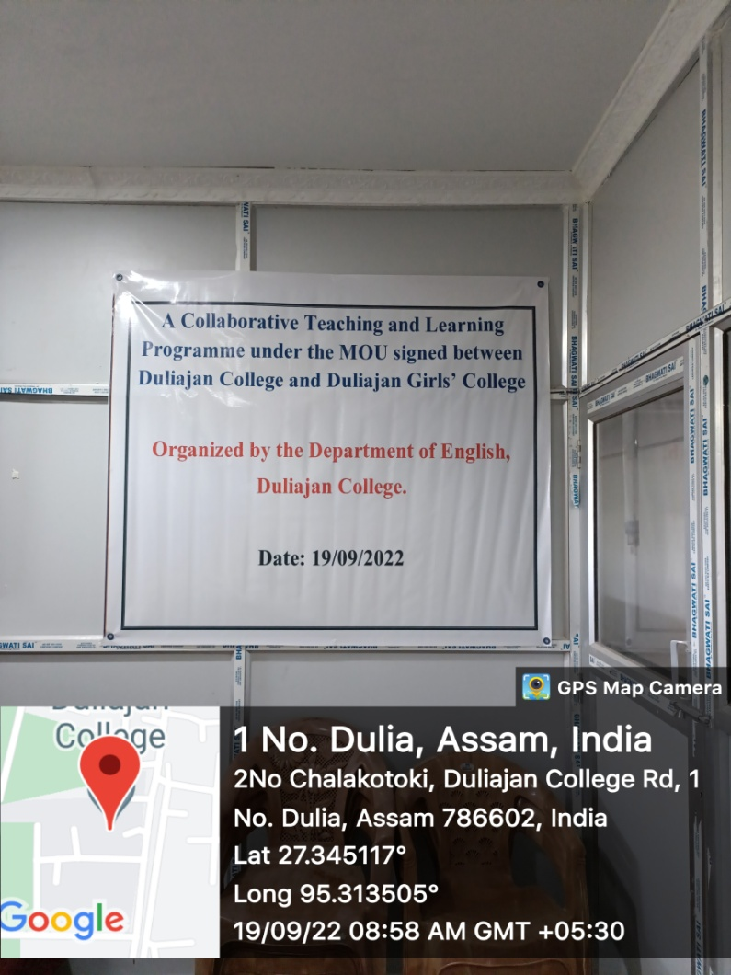

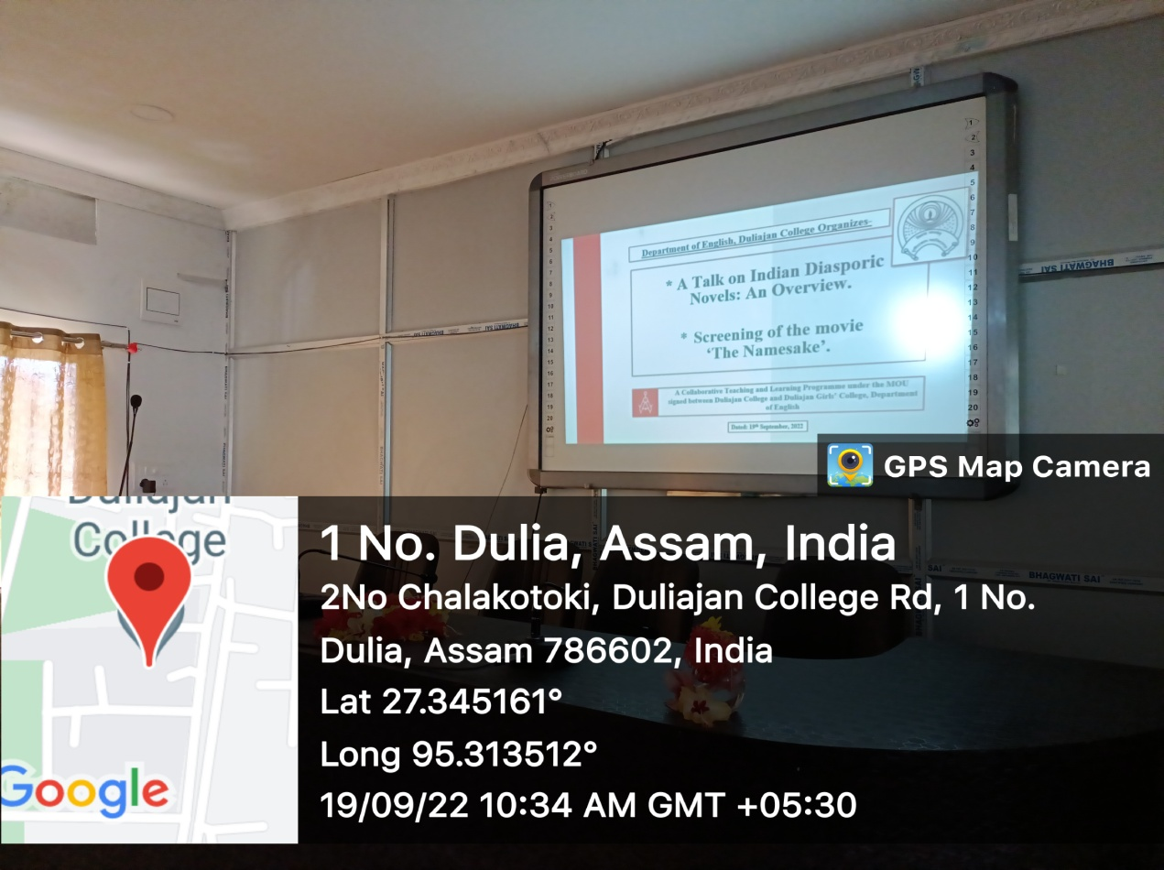

A Lecture on Indian Diasporic Novels: An Overview
and
Screening and critical analysis of ‘The Namesake’

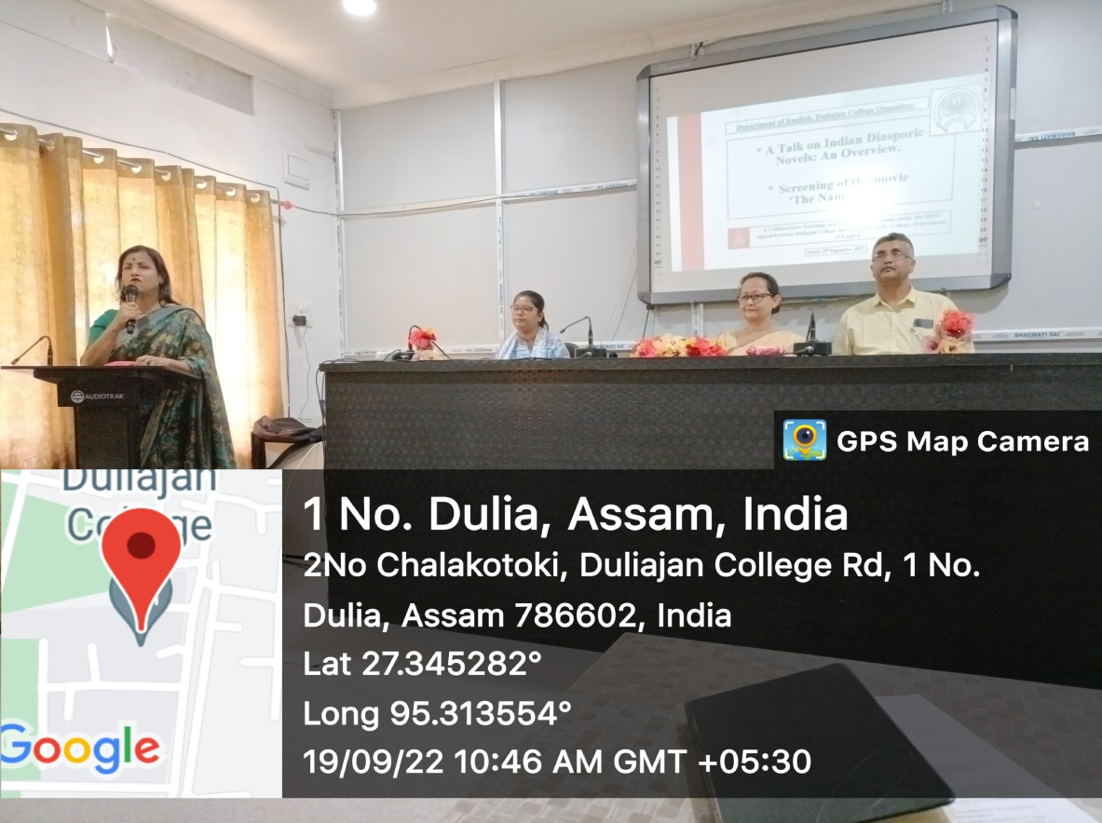

Programme Coordinator: Mrs. Jyoti Singh Pathak- HOD, English, Duliajan College
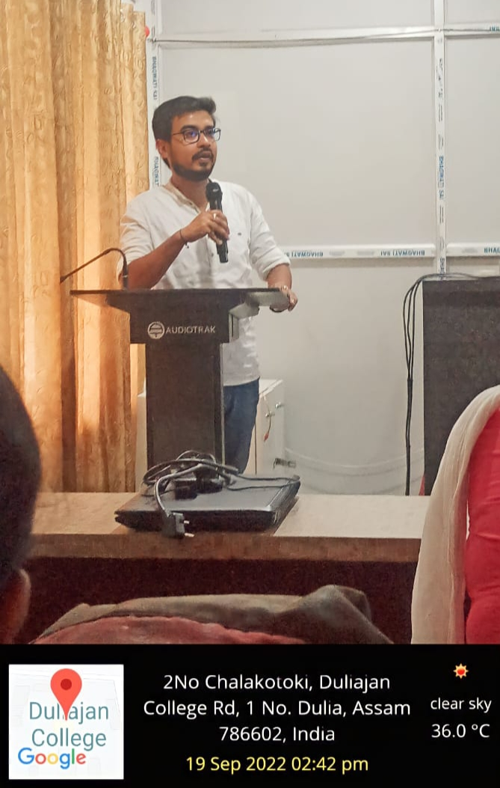

Master of Ceremonies: Mr. Gaurab Sengupta
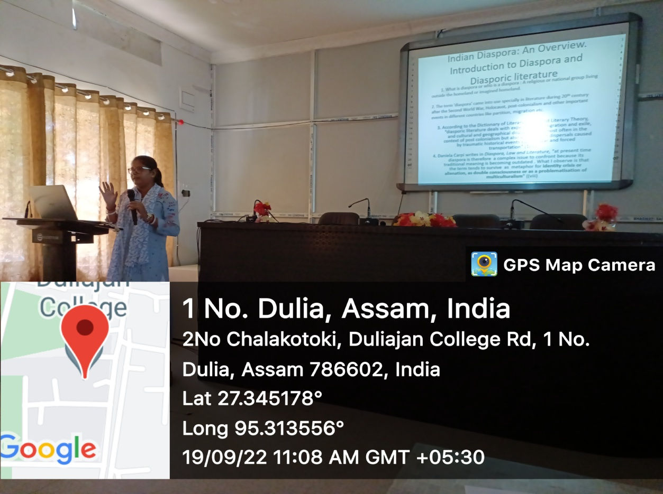

A talk on Indian Diasporic Novels: An Overview. Resource Person: Mrs. Nirupama Dey, Assistant Professor, Department of English, Duliajan College

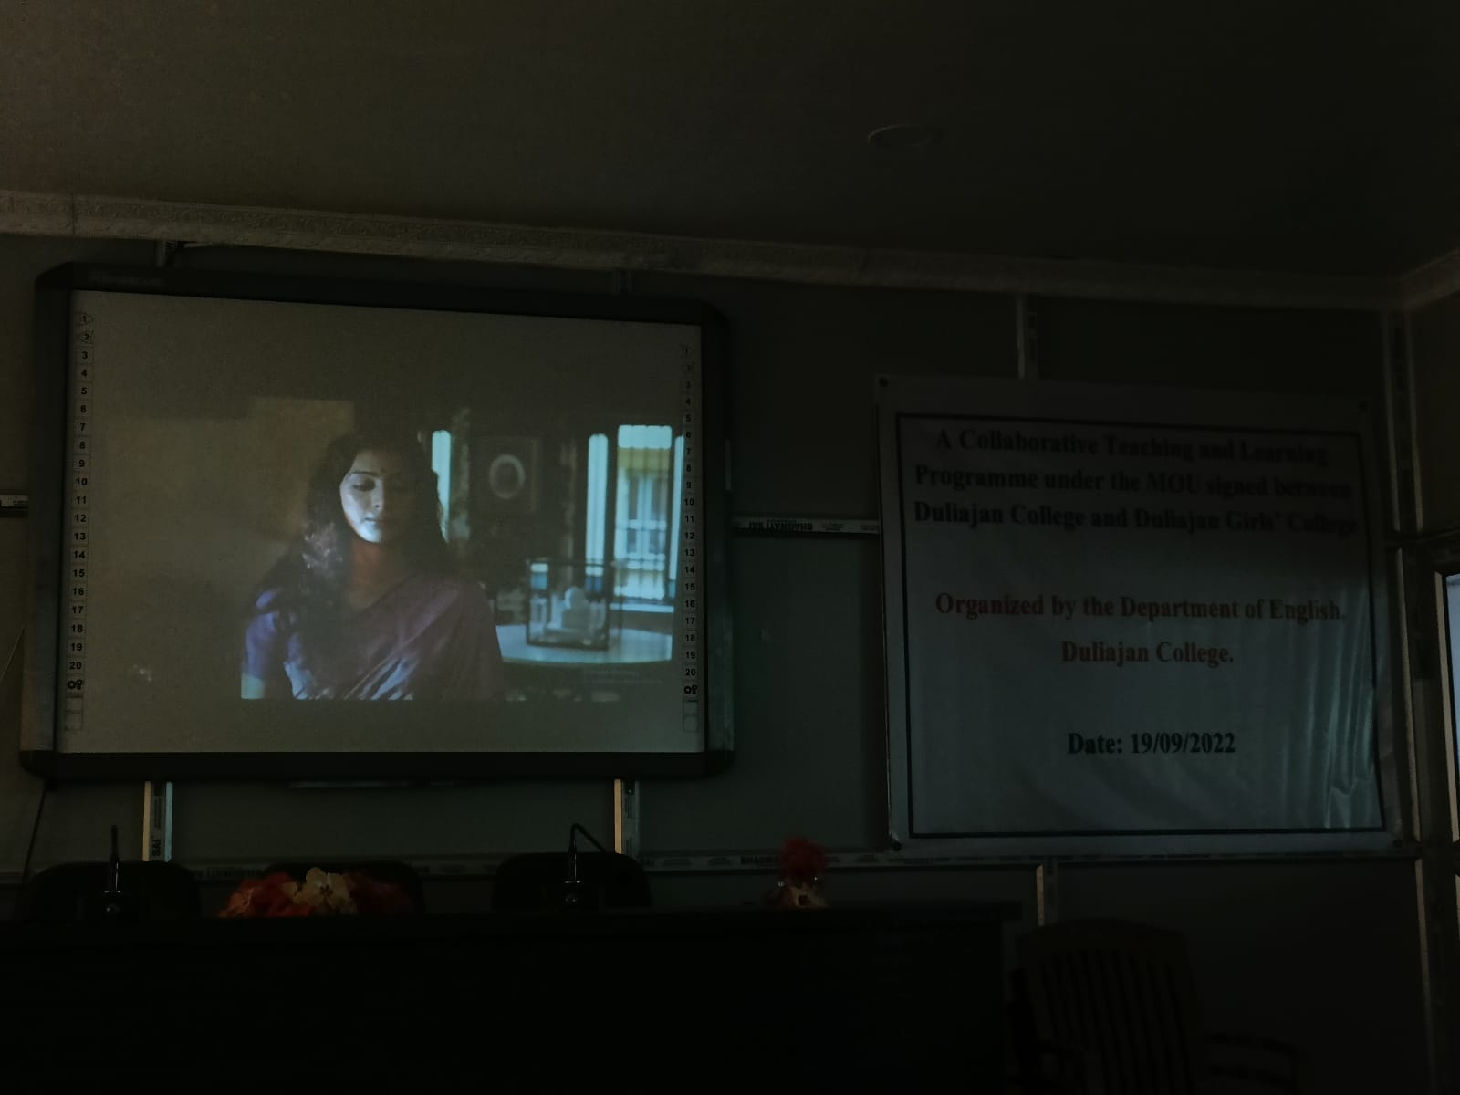

Screening of the film ‘The Namesake’
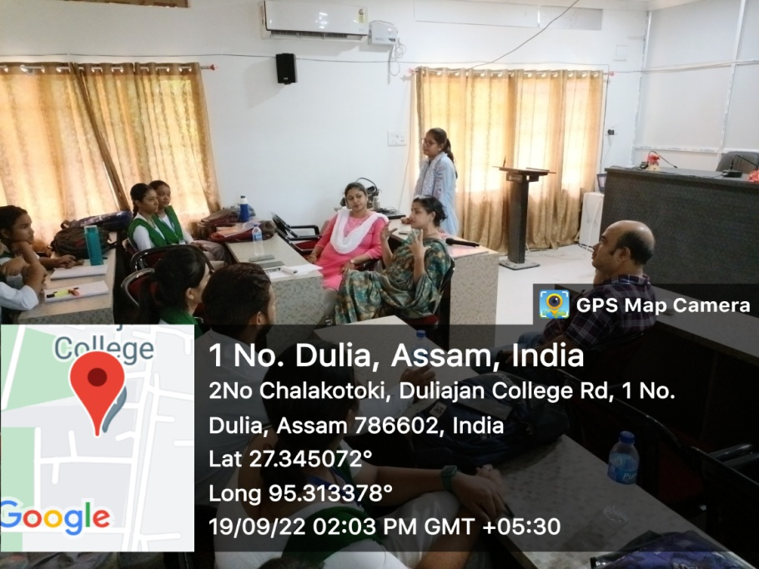

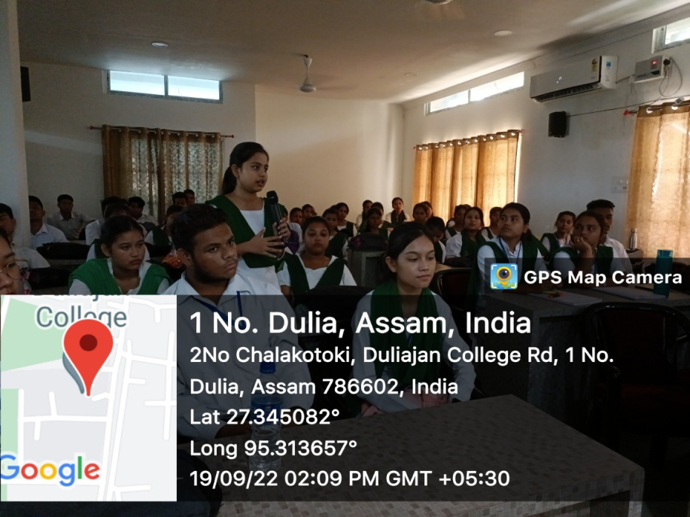

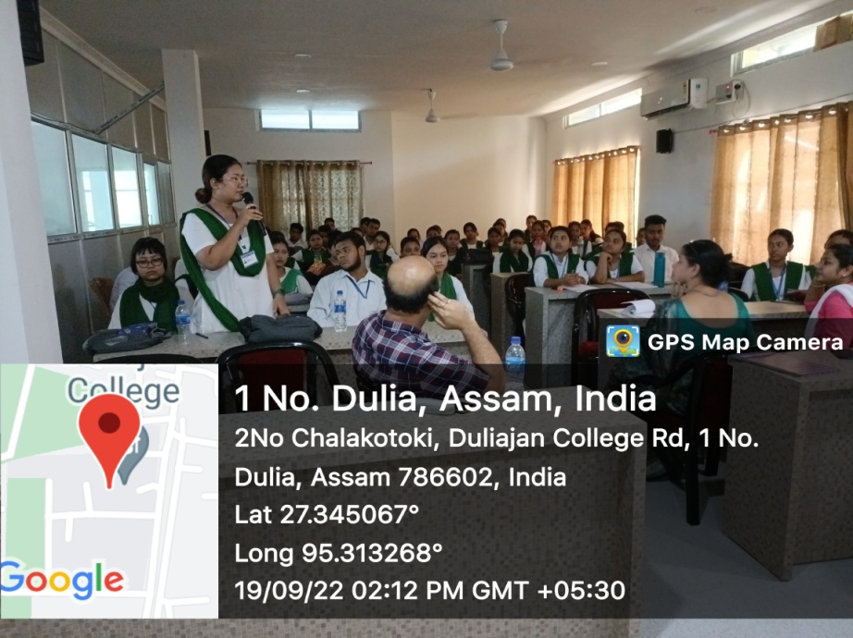

Debrief and analytical session
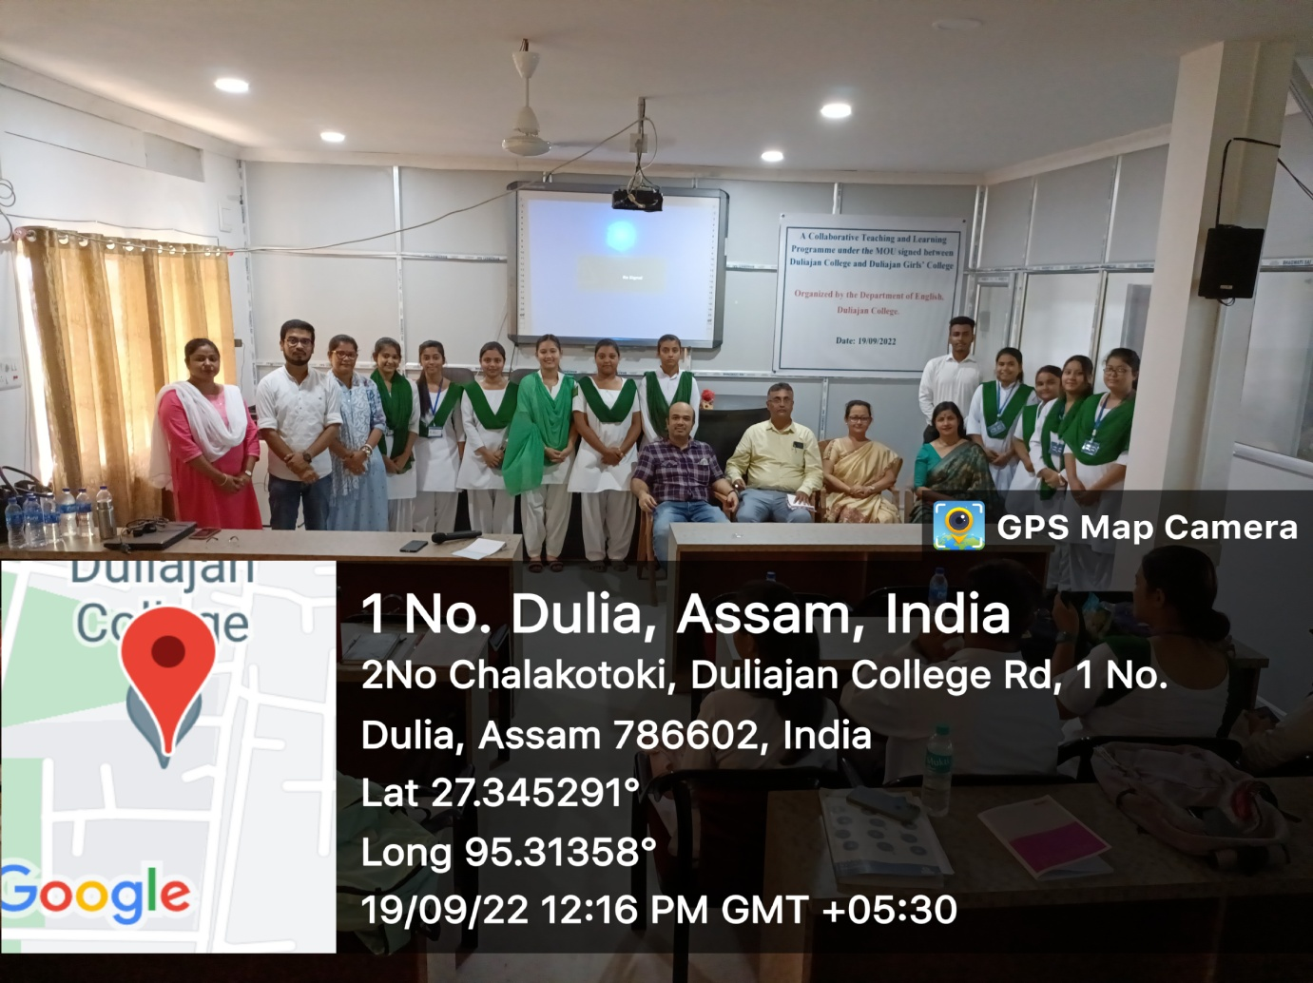
Faculty members: Duliajan College and Duliajan Girls’ College, Department of English and the students of B.A. 5th Semester English Honours- Department of English: Duliajan College and Duliajan Girls’ Collegfe

