Academic Talk on “A Literature of Their Own: Women’s Writing, Feminist Literary Theory and Practice”
29th September 2022
Venue: Seminar Hall Time: 11 AM Onwards

The Department of English, Duliajan College organized an academic talk on “A Literature of Their Own: Women’s Writing, Feminist Literary Theory and Practice” on 29th September, 2022. The Resource Person for the talk was Dr. Madhumita Purkayastha, Associate Professor and former Head at the Department of the English, DHSK College, Dibrugarh. Faculty members and the students of English Department, Duliajan College attended the talk. The program which was hosted by Mr. Gaurab Sengupta, Assistant Professor in the Department of English, Duliajan College, took off its flight with a Welcome address by Mrs. Jyoti Singh Pathak, Head, Department of English, Duliajan College. To set the tone for the discussion, Mrs. Pathak recited ‘Still I Rise’ a poem by Maya Angelou. Dr. Purkayastha provided a thorough presentation on Women’s Writing citing various examples from literary texts, critical theory as well as real-life perspectives. She stated that it is because of women’s writing that the voices of women, which have historically gone unheard, are now being heard and understood by a wider audience. She spoke at length about the various shades of Feminism due to the pluralities in women’s experiences worldwide. In the interactive session moderated by the HOD, faculty members and students actively shared their perspectives. The program ended with an emphasis on gender sensitive behavior and a self composed poem recited by Mrs. Pathak. The vote of thanks was delivered by Mr. Gaurab Sengupta.

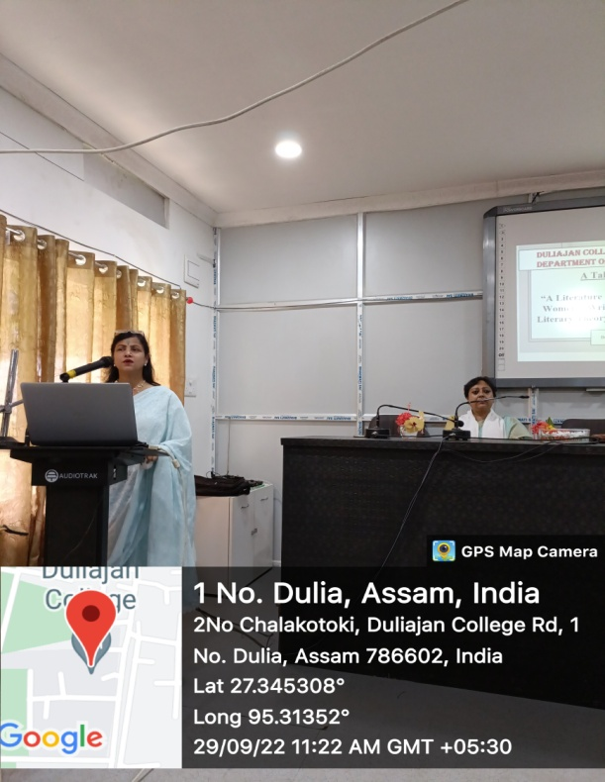
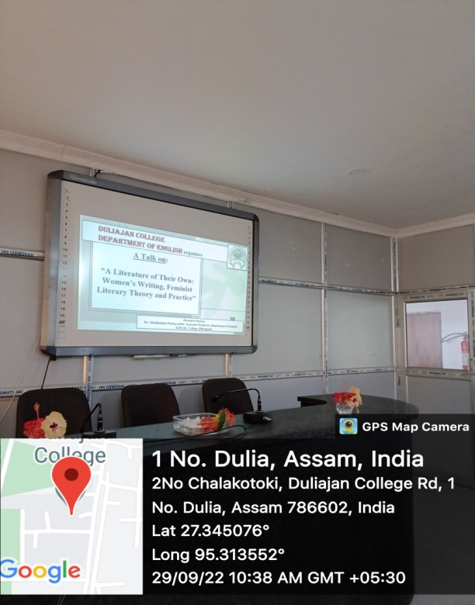
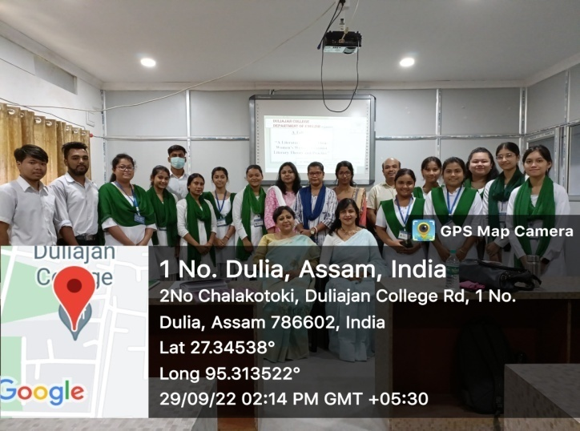
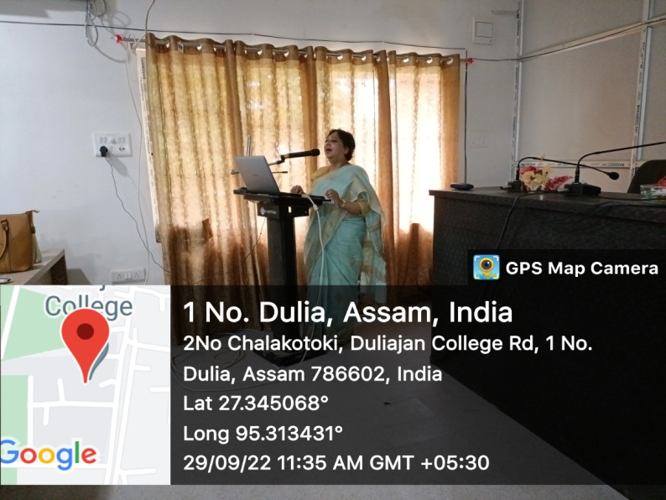
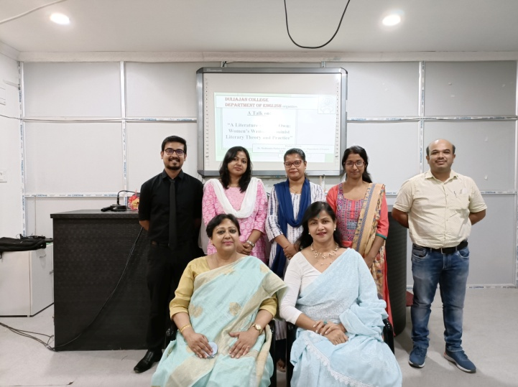
Academic Talk on ‘A Literature of Their Own: Women’s Writing, Feminist Literary Theory and Practice’.
Resource Person: Dr. Madhumita Purkayastha, Associate Professor and Former Head, Department of English, DHSK College, Dibrugarh.
Date: 29th September, 2022

