**My Green Initiative 2023**

**03rd February, 2023**

**Venue: Department of English Time: 10:30 AM**

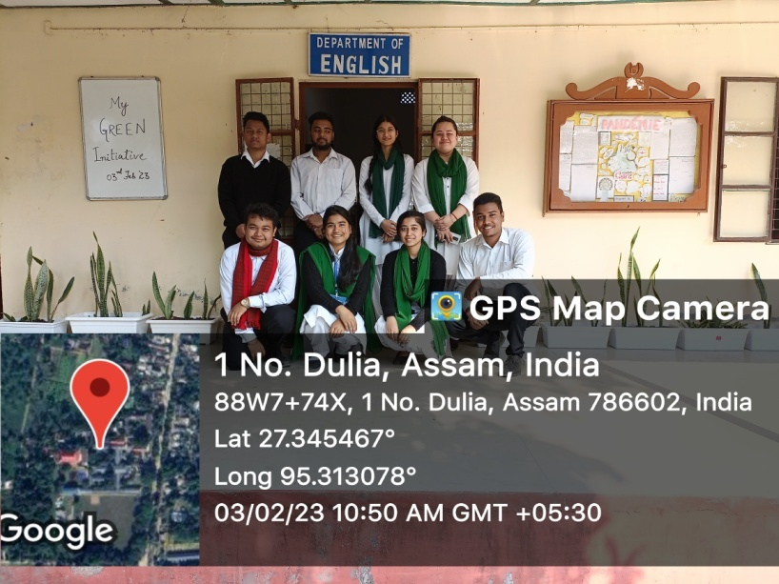

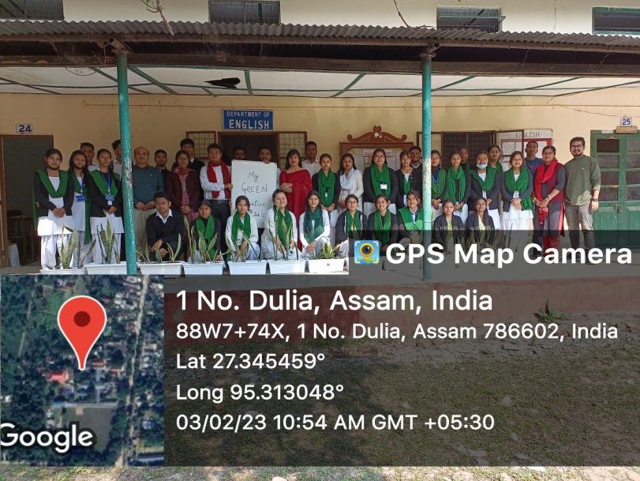

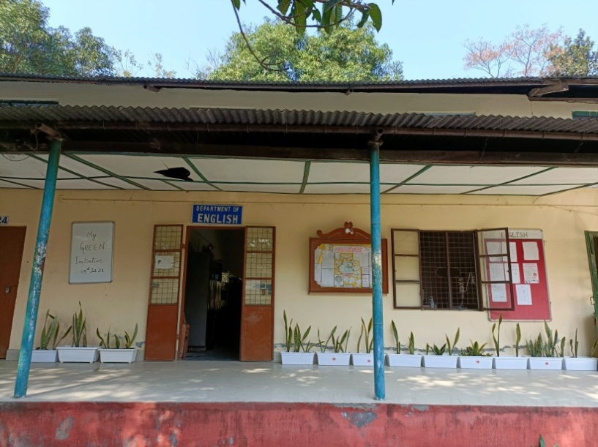

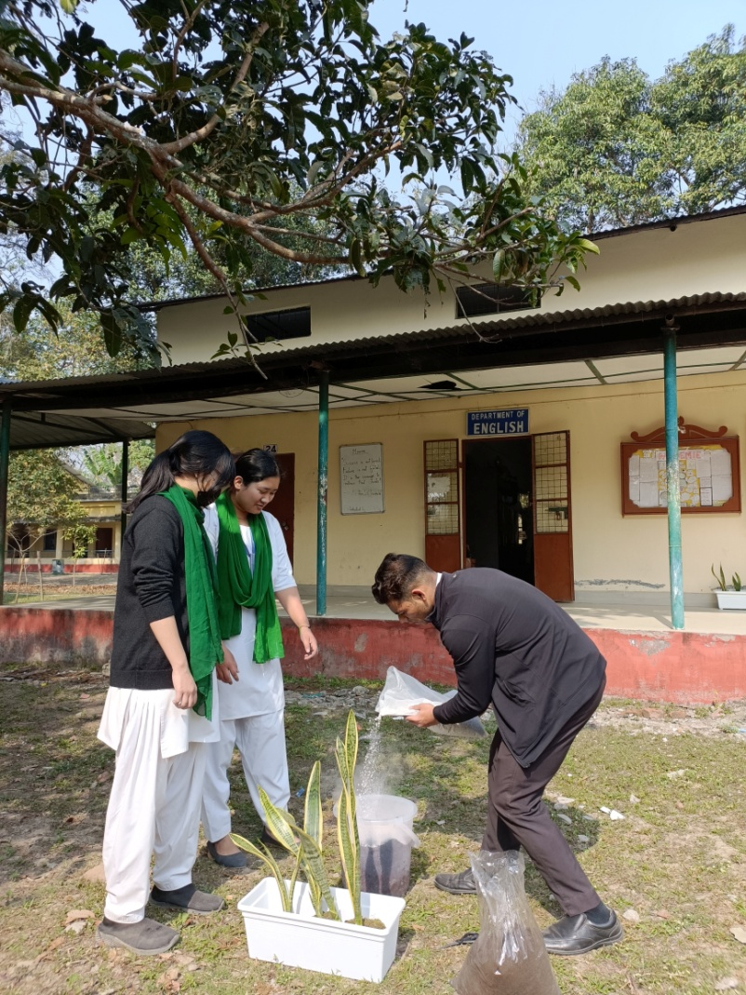

**Objective:**

Collection and preservation of indigenous plants.