Film Screening
2nd February, 2023
Venue: IT Building Time: 01:00 PM Onwards

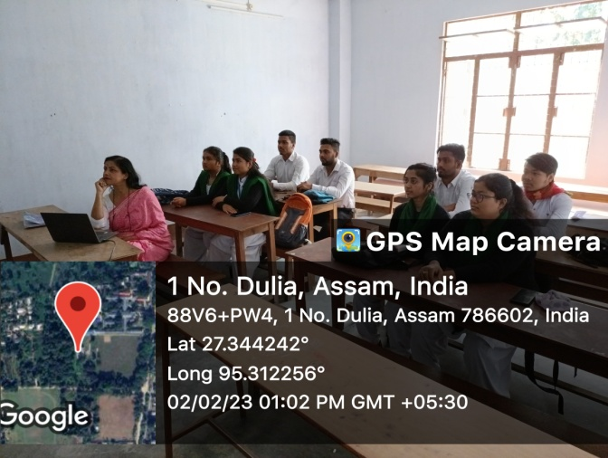
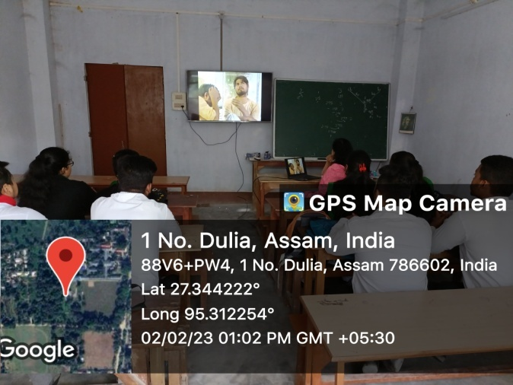
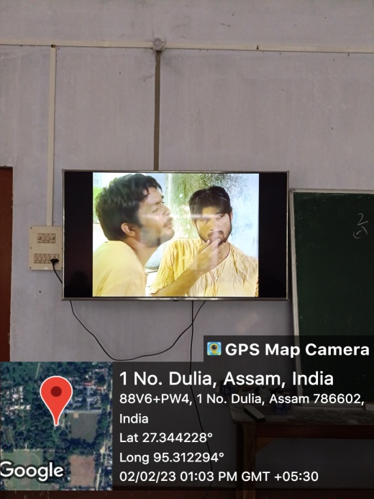

Toba Tek Singh being screened for Semester VI students

