All Assam Inter-College Essay Writing Competition
March 2023

The Department of English, Duliajan College organized an ‘All Assam Inter-College Essay Writing Competition’ to observe International Women’s Day 2023. The essay writing competition was conducted in association with WIPS-Forum of Women in Public Sector, Oil India Limited Cell, Duliajan. In keeping with the theme of International Women’s Day 2023, ‘DigitALL: Innovation and Technology for Gender Equality’, the competition invited essays from students of degree colleges across Assam. A total number of 317 students from various Degree colleges of Assam participated in the essay writing competition.

Program Coordinators:
- Ms. Jyoti Singh Pathak: Associate Professor and Head, Department of English, Duliajan College.
- Mr. Gaurab Sengupta: Assistant Professor, Department of English, Duliajan College.
- Ms. Rajashree Boruah: Assistant Professor, Department of English, Duliajan College.

Broad Objectives:
- Creating awareness on issues related to gender equality.

Specific Objectives:
- Developing writing and critical thinking skills.
- Awareness on the existing digital divide.
- Creative/Critical thinking with regard to solutions.
- Awareness about existing government policies for bridging the gender divide.

Winners of the Essay Competition:
- First Prize: Himangshu Borah, Naharkatiya College, Naharkatiya.
- Second Prize: Gagandeep Kaur, Duliajan College, Duliajan.
- Third Prize: Dinani Dey, Dispur College, Guwahati.
- Consolation: Prasanta Verma, Tinsukia College, Tinsukia.

The cash prize sponsored by WIPS Cell OIL, along with the certificates were distributed to the winners of the competition by Mrs. Binita Deka Borah, President, WIPS Cell and the HOD, Department of English, Mrs. Jyoti Singh Pathak at Duliajan Club during the International Women’s Day celebration organized by WIPS on 07th of March, 2023.

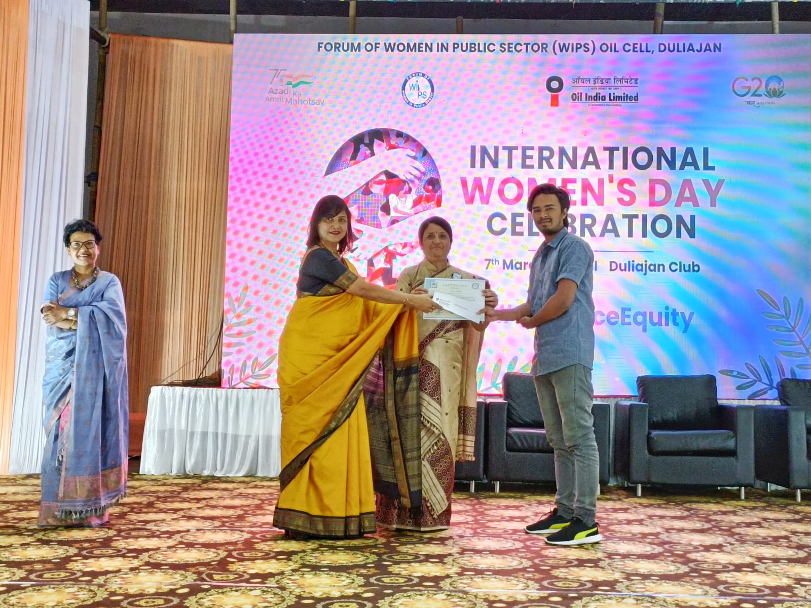
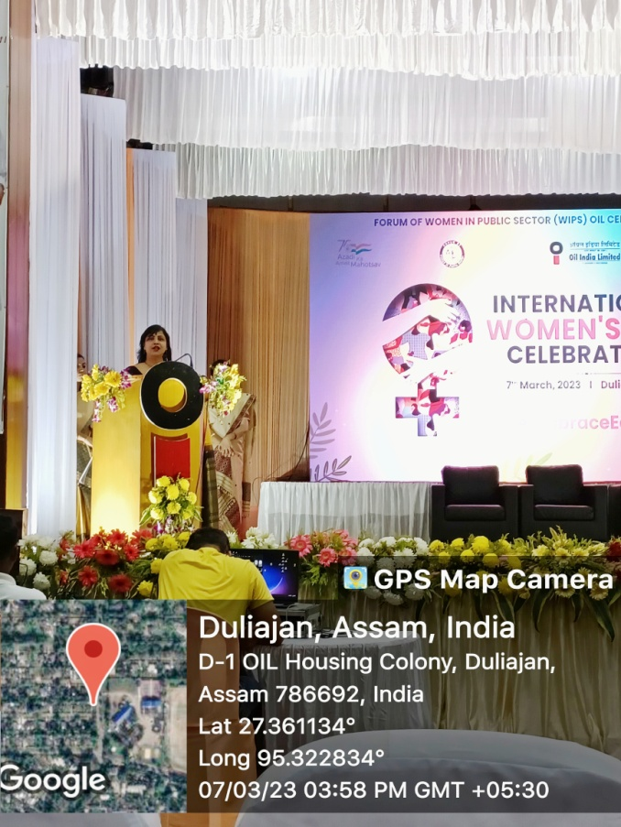

Mrs. Jyoti Singh Pathak delivering her speech

Himangshu Borah: Naharkatiya College receiving the First Prize

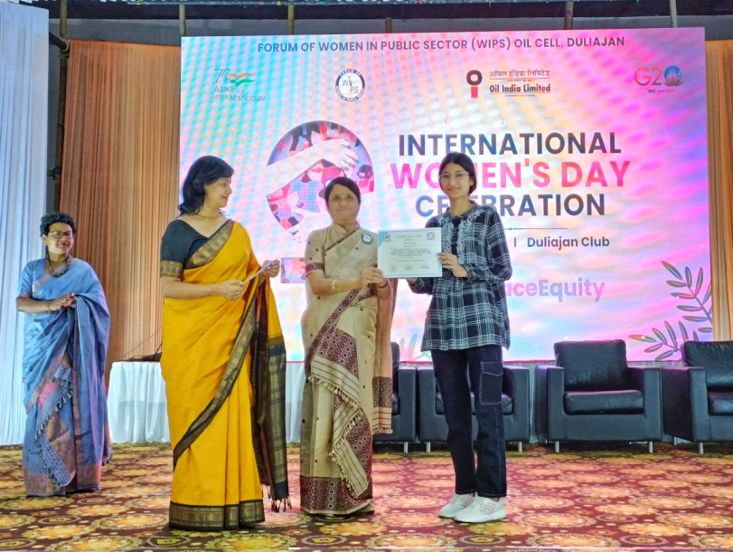
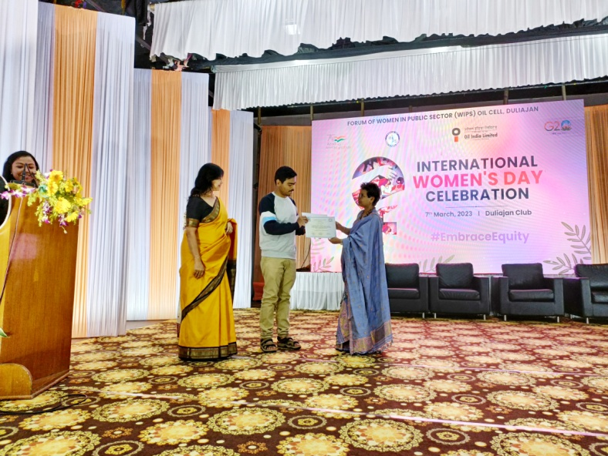
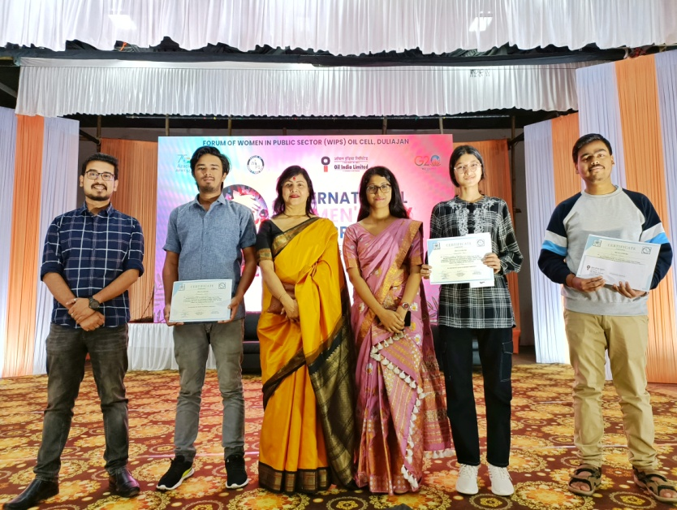
Prasanta Verma, Tinsukia College receiving the Consolation Prize
Gagandeep Kaur, Duliajan College receiving the Second Prize

