Valediction 2023
24th April, 2023
Venue: Room No. 31
Time: 11:00 AM

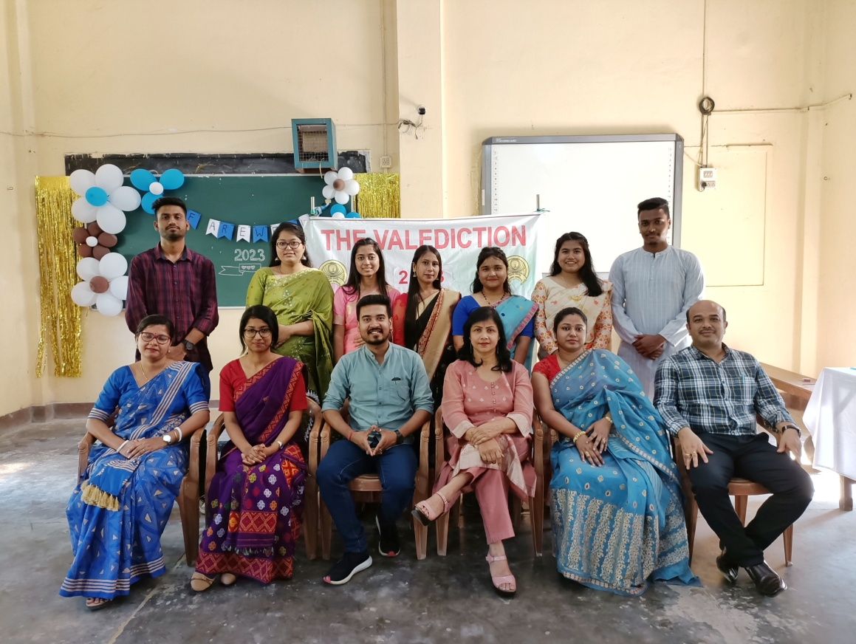

The Department of English organizes a Valediction Ceremony for the outgoing UG batch annually. This ceremony is held every year where the students of all semesters alongside the teachers gather with a primary aim to bid final farewell to the graduating students as the fresh graduates prepare to disperse and step into the next phase of their lives. To celebrate this year’s Valediction, a total number of 45 students were present. The following teachers were also present in the program:
Ms. Jyoti Singh Pathak
Mr. Nayan Jyoti Hazarika
Ms. Pinky Sharma Saikia
Mr. Gaurab Sengupta
Ms. Nirupama Dey
Ms. Rajashree Boruah

This program was organized mainly by the students for the teachers under the guidance of the teachers of the department.

Objectives of the Program:
- To extend best wishes and blessings by the teachers to the outgoing batch.
- To provide a platform to both teachers and students to showcase their talents through various programs like song and dance.
- To provide a platform for student-teacher interaction.
- To strengthen the teacher student bond.
- To enhance and develop event management skills amongst the students.
- To develop the students’ communication skills.
- To enhance team spirit.
Proceedings:
- MOC takes charge.
- Chairperson- Mrs. Jyoti Singh Pathak, Associate Professor and Head, Department of English, Welcome Address.
- Welcome song by students of the department.
- Teachers’ parting message to the students of the outgoing batch.
- Speech by students of the outgoing batch.
- Cake cutting ceremony by the outgoing batch and gifts distribution to the outgoing batch.
- Cultural Program by students of the department.
- Vote of Thanks.
