:: OFFICE OF THE PRINCIPAL ::
:: DULIAJAN COLLEGE, DULIAJAN ::
NOTICE
Ref. No.DC/PO/Misc./Admission/2021/102 Date: 08/09/2021
As per guidelines received from the AHSEC & Govt. of Assam, students seeking admission into H.S. 1st Year (Arts/Science/Commerce) required to visit concerned institution with original documents of H.S.L.C. from 9th September 2021 to 11th September 2021.

In order to confirm their admission at Duliajan College, Duliajan a student need to follow the below mentioned guidelines:

- A student need to bring H.S.L.C. Registration Card, Admit Card, Marksheet, Certificate (Original documents without Lamination)
- For students under Reserved Category needs to produce Original Caste Certificate of the student.
- For Fees Structure visit www.duliajancollegeonline.co.in (PROSPECTUS)
- Students seeking FREE ADMISSION need to produce:
- A self declaration Form (attached herewith this notice)
- An Income Certificate below annual family income of Rs. 2 Lakhs obtained from respective Revenue Circle Officer. (Income certificate obtained from any other source will not be accepted as per govt. notification).
- FREE ADMISSION does not mean that they need not have to pay any amount
Students who will be offered FREE ADMISSION will have to pay an amount of Rs. 670/-
- In addition to the FEES mentioned in the prospectus or the Fees mentioned above for FREE ADMISSION, if a student choose/opt any one of the below mentioned Self Financing subject(s) have to pay an ADDITIONAL FEES of Rs. 1500/- (One Time for H.S. Course i.e. H.S. 1st Year and H.S. 2nd Year)

Self Financing Subjects under Duliajan College, Duliajan: 1) Computer Science 2) Hindi
- For payment purpose, we accept Google Pay or Hard Cash only (Preferably Google Pay).

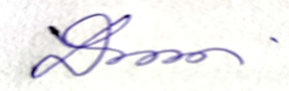
(Dr. Lok Bikash Gogoi)
Principal
Duliajan College, Duliajan
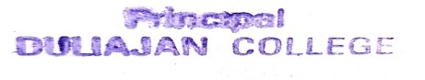

DECLARATION BY THE STUDENT & PARENT

Affix a Photograph of Tree Plantation by the concerned student…
Mention the name of the Tree Planted…

I, Sri / Miss _____________________________________________, son/daughter of Mr. / Mrs. ___________________________________________ _______________________ inhabitant of ______________________________ ________________________________ hereby declare that neither of my parents (Father/mother) is working in the State/Central Govt./Semi Govt/State or Central Govt. undertakings.

If my declaration is found false, the authority deserves the right to take necessary measures against my admission.

Further, I have affixed an Income Certificate from the Local Revenue Circle officer.

____________________ ________________________
Signature of Parent Signature of the Student
Class:

