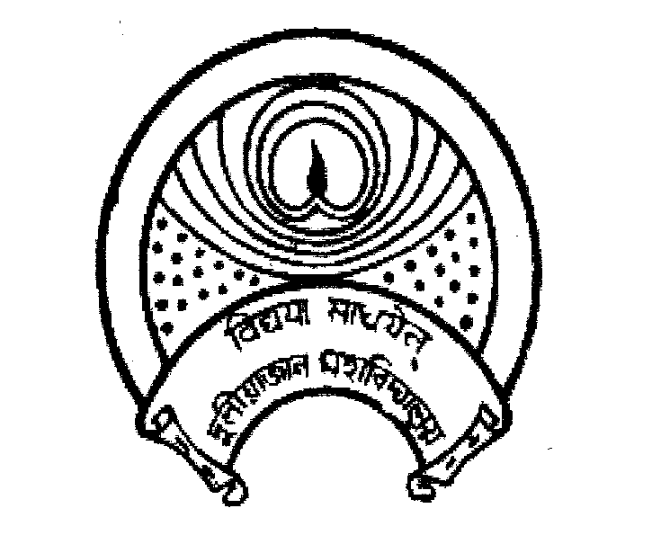
দুলীয়াজান মহাবিদ্যালয়
DULIAJAN COLLEGE
P.O. DULIAJAN – 786 602, Dist. Dibrugarh, Assam.
Phone: 0374-2800356, e-Mail : duliajancollege@yahoo.com, Website : www.duliajancollege.in
NAAC Re-Accredited(3rd Cycle) with B+ Grade
(Registered Under The Societies Registration Act.XXI of 1860)
Registration No. 279 of 1977-78
Under Section 2(F) and 12(B) of the UGC Act, 1956
Ref. No.: DC/PO/Misc./PTM/2025/182 Date: 18/08/2025

Notice

All the faculty members of Arts Stream are hereby informed that a “Parent-Teacher Meet” for the First Semester students of Arts Stream will be held on 19th August 2025 at 11:30 a.m. in the College Auditorium. The purpose of this meeting is to discuss the academic progress, attendance as well as to strengthen communication between parents and faculties for the betterment of the learners. Faculty members are requested to make necessary preparations, keep the attendance records ready, and ensure invitation to all the parents of the
first semester students of their departments. Further, all the HODs of Arts stream are also invited to the meeting. It is also informed that all the remaining classes will be held as per allotted class routine.

Program Date: 19th August, 2025
Time: 11.00 am
Venue: Auditorium

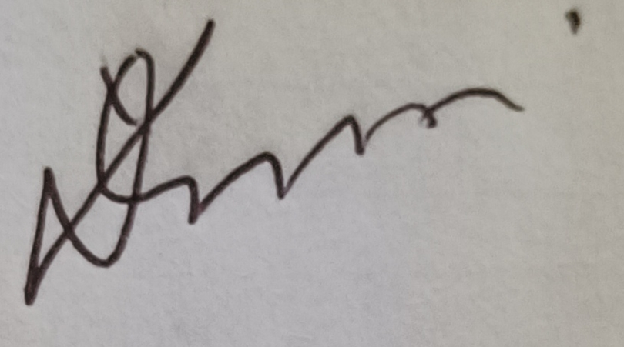
(Dr. Lok Bikash Gogoi)
Principal,
Duliajan College, Duliajan
