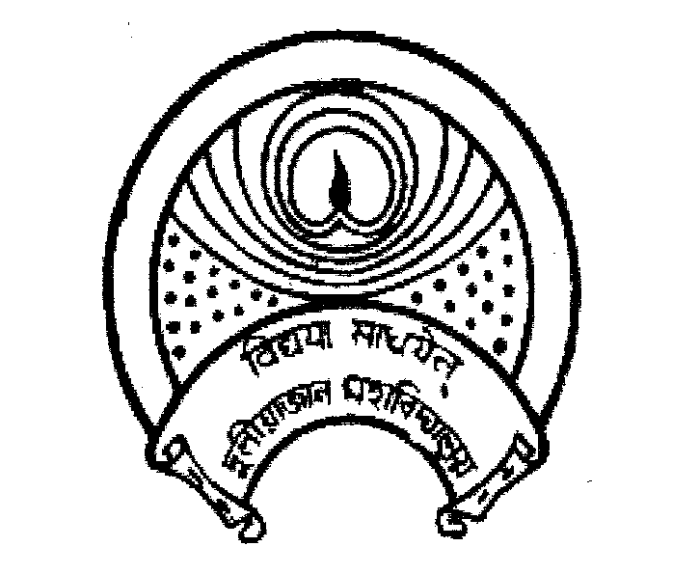
দুলীয়াজান মহাবিদ্যালয়
DULIAJAN COLLEGE
P.O. DULIAJAN – 786 602, Dist. Dibrugarh, Assam.
Phone: 0374-2800356, e-Mail : duliajancollege@yahoo.com, Website : www.duliajancollege.in
NAAC Re-Accredited(3rd Cycle) with B+ Grade
(Registered Under The Societies Registration Act.XXI of 1860)
Registration No. 279 of 1977-78
Under Section 2(F) and 12(B) of the UGC Act, 1956
Ref. No.: DC/PO/Misc./Freshers/2025/190(a) Date: 22/08/2025

Notice

All the teaching and non-teaching staff members, as well as students of Duliajan College, are hereby informed that the Freshers’ Social of the college will be held on 23/08/2025 (Saturday).
- Time of commencement: 8:45 AM (sharp)
- Arrival of Chief Guest for the Open Meeting: 9:15 AM
All concerned are informed to be present in the college premises by 8:45 AM positively to ensure the smooth conduct of the programme.

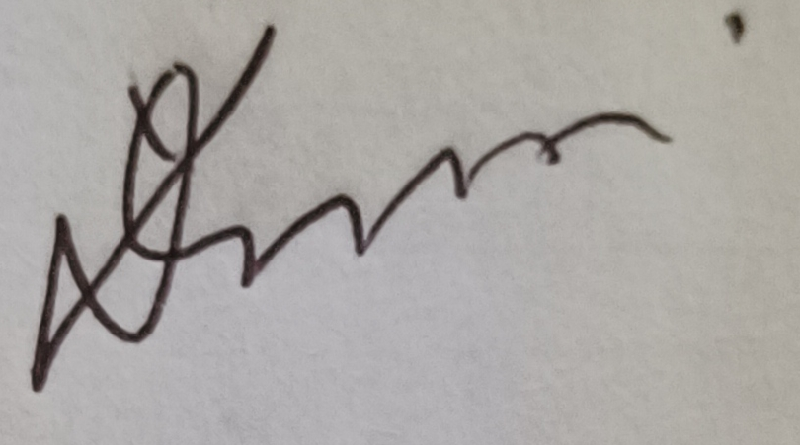
(Dr. Lok Bikash Gogoi)
Principal,
Duliajan College, Duliajan
